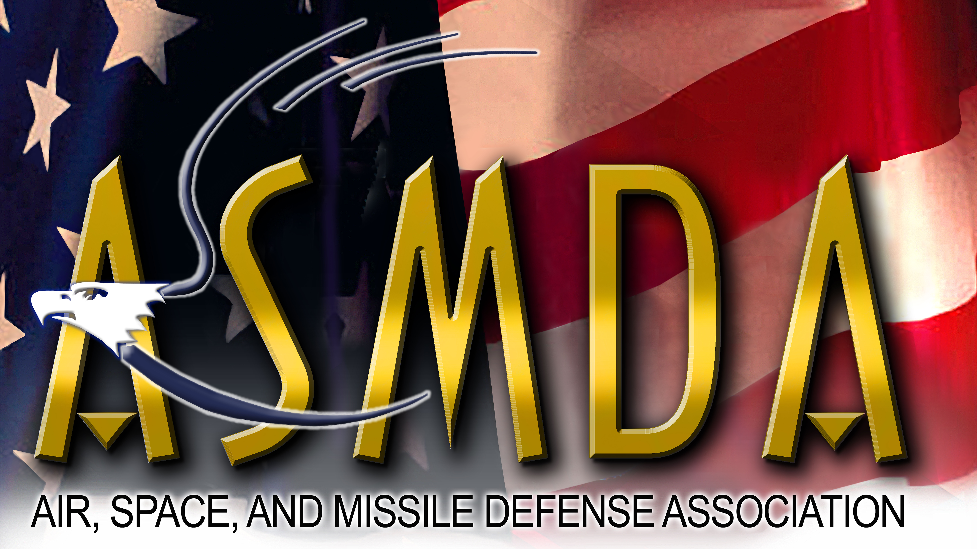

Air, Space, and Missile Defense Association

P.O. Box 11001, Huntsville, Alabama 35816

May 1, 2021

All Sponsored Organizations, Individual Members, and Corporate Members of the Air, Space, and Missile Defense Association

SUBJECT: ASMDA 2021 Mayor Loretta Spencer University Scholarship Program

Dear Members and Friends,

The Air, Space and Missile Defense Association (ASMDA) is proud to announce that for the seventeenth consecutive year we will be offering college scholarships to deserving students in the Air, Space and Missile Defense community through the Mayor Loretta Spencer University Scholarship Fund. This year ASMDA will select four undergraduate (juniors or seniors only) or graduate students majoring in science or engineering to each receive a $4,000 Scholarship Award. These scholarships will be presented during the annual Space and Missile Defense Symposium in August 2021.

The Mayor Loretta Spencer University scholarships are available to individual ASMDA members and their immediate family members, corporate members’ employees and their immediate family members, as well as military and civilian personnel currently assigned to sponsored government organizations and their immediate family members. Attached is an information sheet that describes eligibility and application requirements, selection criteria, and the application schedule. Please help get the word out to others within your organization and to deserving students by disseminating this information paper and encouraging eligible students to apply. Applications are due by June 30, 2021.

ASMDA is looking forward to reviewing many applications and continuing the long Huntsville tradition of supporting the advancement of higher education and the study of science and engineering.

Thank you for your support,

David M. Poehlein

David M. Poehlein
Chairman, ASMDA Scholarship Committee

1 Attachment – Scholarship Information Sheet

2021 MAYOR LORETTA SPENCER SCHOLARSHIP PROGRAM
IN COORDINATION WITH THE
AIR, SPACE AND MISSILE DEFENSE ASSOCIATION (ASMDA)

The 2021 Mayor Loretta Spencer Scholarship Fund in coordination with the Air, Space and Missile Defense Association (ASMDA) will select four undergraduate (juniors and seniors only) or post-graduate students to each receive a $4,000 Scholarship Award ($16,000 in total awards). Awards will be made in August 2021 during the annual Space and Missile Defense Symposium.

Eligibility Requirements:
- U.S. Citizen
- Scholarships are available to: ASMDA members, employees of corporate members identified as current corporate sponsors, and employees of: the Rapid Capabilities and Critical Technologies Office (RCCTO), US Army Space and Missile Defense Command (SMDC); PEO Missiles and Space; US Army Aviation and Missile Command (AMCOM); the U.S. Army Combat Capabilities Development Command Aviation & Missile Center (CCDC AvMC); the Missile and Space Intelligence Center (MSIC); the Missile Defense Agency (MDA); and the NASA Marshall Space Flight Center (MSFC). Eligibility extends to military and civilian personnel of the above organizations, employees of ASMDA corporate sponsors, and individual AMSDA members. Immediate family members (spouse/children only) in all the previous categories are also eligible.
- Under-graduate student – Must be a junior or senior in the fall of 2021, currently enrolled in a “hard” science (Engineering, Biology, Chemistry, Physics, Math or related field) at an accredited college or university
- Graduate student - pursuing a graduate degree in a “hard” science (Engineering, Biology, Chemistry, Physics, Math or related field)
- Student in good academic standing

Application Procedure:
Provide the following three documents to the Scholarship Committee:
- A brief (not more than one page) biographical sketch that includes:
    - Full name, address, phone number(s), and email address where you can be contacted
    - How the applicant meets scholarship eligibility requirements above (be specific as to how the applicant meets all the above eligibility criteria; be specific and address each point directly)
    - Awards received
    - Community service involvement
    - Organizations and activities in which the student is actively involved
    - Where financial need exists, please explain in a short paragraph
- A copy of the student’s latest transcript (official copy from the institution but it does not have to be mailed by the university)
- A one-page essay that describes the student’s area of study and how it relates to air, space and/or missile defense

Selection Criteria:
- Must meet all eligibility requirements
- Level of academic standing and community involvement
- Potential for significant contributions to air, space and/or missile defense (based on essay)
- Likelihood that the individual will pursue a career in area(s) directly or indirectly related to air, space and missile defense
- Financial need

Schedule:
- Application materials must be received by June 30, 2021.
- Selections will be made and awardees notified the week of 26 July, 2021.
- Awards will be made in August 2021 during the annual Space and Missile Defense Symposium.

Application Materials should be mailed or hand-carried to:
Intuitive Research and Technology Corporation
ASMDA 2021 Mayor Loretta Spencer Scholarship Selection Committee
ATTN: David Poehlein (Committee Chair)
5030 Bradford Drive
Building 2, Suite 205
Huntsville, AL 35805

