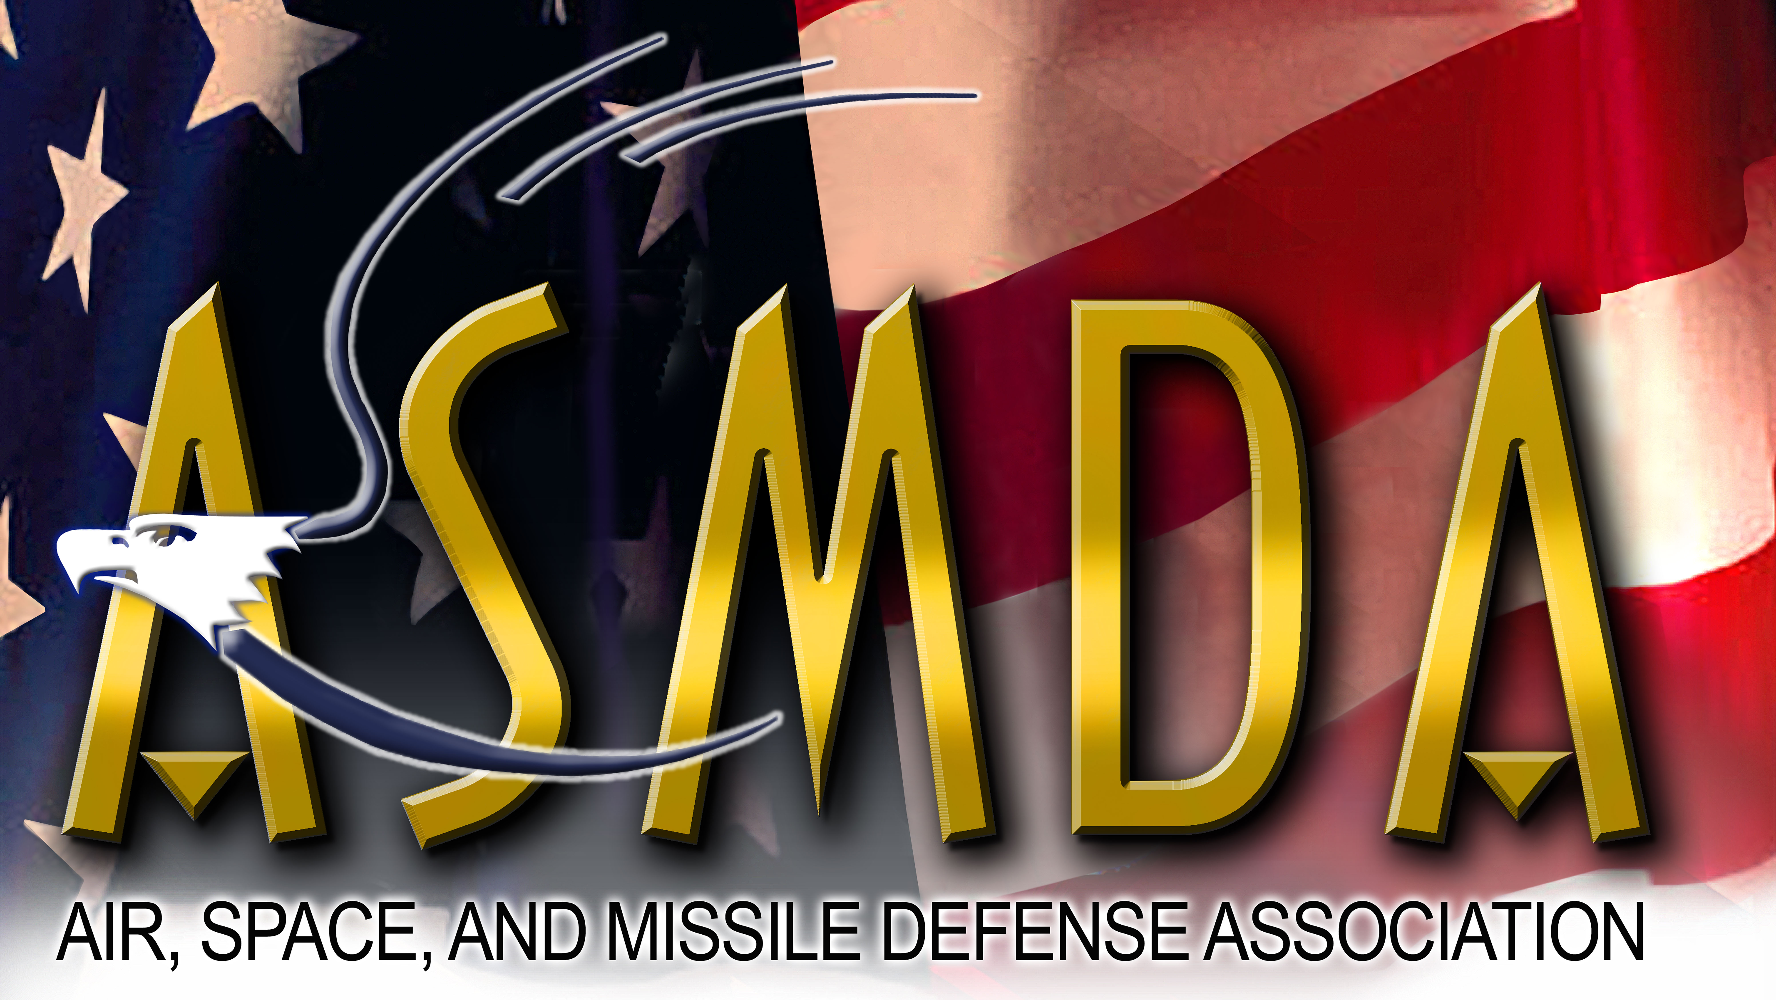

Air, Space, and Missile Defense Association

P.O. Box 11001, Huntsville, Alabama 35816

May 1, 2021

All Sponsored Organizations, Individual Members, and Corporate Members of the Air, Space, and Missile Defense Association

SUBJECT: ASMDA 2021 Lieutenant General Larry Dodgen Memorial University Scholarship Program

Dear Members and Friends,

The Air, Space and Missile Defense Association (ASMDA) announces the 2021 college scholarship program in honor of Lieutenant General Larry Dodgen who dedicated his life to the defense of our nation and to enhancing our nation’s ability to protect its citizens and troops from attack from enemy airborne and ballistic missile systems. This year we will be offering a $4000 college scholarship to one deserving student in the Air, Space and Missile Defense community through the ASMDA University Scholarship Fund. This scholarship will be presented during the annual Space and Missile Defense Symposium in August 2021.

The Lieutenant General Larry Dodgen Memorial University scholarship is available to Active Duty Army Soldiers, Reserve Soldiers, and National Guard Soldiers currently working for or assigned to: Rapid Capabilities and Critical Technologies Office (RCCTO), US Army Space and Missile Defense Command (SMDC); PEO Missiles and Space; US Army Aviation and Missile Command (AMCOM); U.S. Army Combat Capabilities Development Command Aviation & Missile Center (CCDC AvMC), Missile and Space Intelligence Center (MSIC); Missile Defense Agency (MDA); and NASA Marshall Space Flight Center (MSFC). The scholarship is also available to these Soldiers’ spouses and children. Attached is an information sheet that describes eligibility requirements, application requirements, selection criteria, and the application schedule. Please help get the word out to others within your organization and to deserving students by disseminating this information paper and encouraging eligible students to apply. Applications are due no later than June 30, 2021.

ASMDA is looking forward to reviewing many applications and continuing the long Huntsville tradition of supporting the advancement of higher education.

Thank you for your support,

David M. Poehlein

David M. Poehlein
Chairman, ASMDA Scholarship Committee

1 Attachment – Scholarship Information Sheet

2021 LIEUTENANT GENERAL LARRY DODGEN MEMORIAL SCHOLARSHIP PROGRAM
IN COORDINATION WITH THE
AIR, SPACE AND MISSILE DEFENSE ASSOCIATION (ASMDA)

The 2021 Lieutenant General Larry Dodgen Memorial Scholarship Fund in coordination with the Air, Space and Missile Defense Association (ASMDA) will select one college student to receive a $4,000 Scholarship Award. Award will be made in August 2021 during the annual Space and Missile Defense Symposium.

Eligibility Requirements:
- U.S. Citizen
- Scholarship is available to: Active Duty Army Soldiers, Army Reserve Soldiers, and Army National Guard Soldiers currently working for or assigned to: the Rapid Capabilities and Critical Technologies Office (RCCTO), US Army Space and Missile Defense Command (SMDC); PEO Missiles and Space; US Army Aviation and Missile Command (AMCOM); the U.S. Army Combat Capabilities Development Command Aviation & Missile Center (CCDC AvMC); the Missile and Space Intelligence Center (MSIC); the Missile Defense Agency (MDA); and the NASA Marshall Space Flight Center (MSFC). Spouses and children of these soldiers are also eligible.
- Must be enrolled in a degree producing, college-level program in the fall of 2021 at any level (College Freshman through Graduate Studies) at an accredited college or university.
- Student in good academic standing

Application Procedure:
Provide the following three documents to the Scholarship Committee:
- A brief (not more than one page) biographical sketch that includes:
    - Full name, address, phone number(s), and email address where you can be contacted
    - How the applicant meets scholarship eligibility requirements above (be specific as to how the applicant meets all the above eligibility criteria; be specific and address each point directly)
    - Awards received
    - Community service involvement
    - Organizations and activities in which the student is actively involved
    - Where financial need exists, please explain in a short paragraph
- A copy of the student’s latest transcript (official copy from the institution but it does not have to be mailed by the university or high school (in the case of new college freshmen)
- A one-page essay that describes the student’s area of study and how this will prepare them to be a productive member of society upon graduation

Selection Criteria:
- Must meet all eligibility requirements
- Level of academic achievement
- Financial need
- Demonstrated leadership and community contributions
- Enrolled in a degree producing program in an Accredited College or University as a Freshman thru Graduate Level (any Degree Producing Program) for the Fall of 2021
- Potential to make a contribution to society upon graduation (based on essay)

Schedule:
- Application materials must be received by June 30, 2021.
- Selection will be made and the awardee notified the week of July 26, 2021
- Award will be made in August 2021 during the annual Space and Missile Defense Symposium.

Application Materials should be mailed or hand-carried to:

Intuitive Research and Technology Corporation
ASMDA 2021 LTG Larry Dodgen Memorial Scholarship Selection Committee
ATTN: David Poehlein (Committee Chair)
5030 Bradford Drive
Building 2, Suite 205
Huntsville, AL 35805

